QRCode that usages image tag
and will get replaced from the internet.

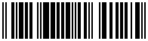
QRCode that usage the barcode tag.

The following image has base64 as source:

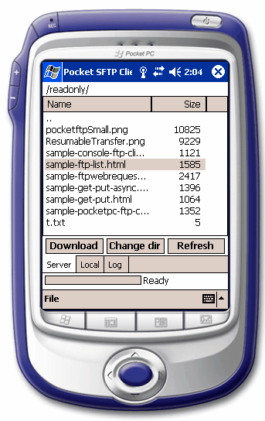

You can also use the images from ftp sources: ->

