Demo to show the usage of Column Break in DOCX.

1. Business Shirt

Wrinkle-free cotton business shirt
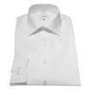
Category : Mens
Price : 50 USD

2. Trousers

Black trousers suitable for every business man
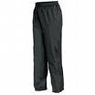
Category : Mens
Price : 80 USD

3. Jacket

Fully lined jacket which is both professional and extremely comfortable to wear
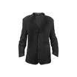
Category : Mens
Price : 150 USD

4. Blouse

Silk blouse ideal for all business women
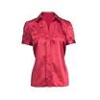
Category : Womens
Price : 60 USD

5. Skirt

Wrinkle free skirt
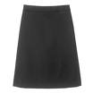
Category : Womens
Price : 80 USD

6. Ladies Shoes

Low heel and cushioned interior for comfort and style in simple yet elegant shoes
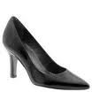
Category : Womens
Price : 120 USD

