Demo to show the usage of Interactive Grid in DOCX.
IGRID1
Product Id | Product Name | Product Description | Category | Product Avail | List Price | Tags
1 | Business Shirt | Wrinkle-free cotton business shirt | Mens | Y | 50 | Top seller
2 | Trousers | Black trousers suitable for every business man | Mens | Y | 80 | Top seller
3 | Jacket | Fully lined jacket which is both professional and extremely comfortable to wear | Mens | Y | 150 | NULL_IG
4 | Blouse | Silk blouse ideal for all business women | Womens | Y | 60 | NULL_IG
5 | Skirt | Wrinkle free skirt | Womens | Y | 80 | NULL_IG
6 | Ladies Shoes | Low heel and cushioned interior for comfort and style in simple yet elegant shoes | Womens | Y | 120 | NULL_IG
7 | Belt | Leather belt | Accessories | Y | 30 | NULL_IG
8 | Bag | Unisex bag suitable for carrying laptops with room for many additional items | Accessories | Y | 125 | NULL_IG
9 | Mens Shoes | Leather upper and lower lace up shoes | Mens | Y | 110 | NULL_IG
10 | Wallet | Travel wallet suitable for men and women. Several compartments for credit cards, passports and cash | Accessories | Y | 50 | NULL_IG

IGRID2
Product Id | Product Name | Product Description | Category | Product Avail | List Price | Product Image | Mimetype | Filename | Image Last Update | Tags
1 | Business Shirt | Wrinkle-free cotton business shirt | Mens  New line with HTML | Y | 50 | 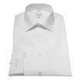 | image/jpeg | shirt.jpg | 09-MAY-2023 | Top seller
2 | Trousers | Black trousers suitable for every business man | Mens  New line with HTML | Y | 80 | 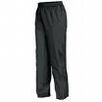 | image/jpeg | pants.jpg | 09-MAY-2023 | Top seller
3 | Jacket | Fully lined jacket which is both professional and extremely comfortable to wear | Mens  New line with HTML | Y | 150 | 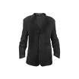 | image/jpeg | jacket.jpg | 09-MAY-2023 | -
4 | Blouse | Silk blouse ideal for all business women | Womens  New line with HTML | Y | 60 | 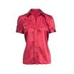 | image/jpeg | blouse.jpg | 09-MAY-2023 | -
5 | Skirt | Wrinkle free skirt | Womens  New line with HTML | Y | 80 | 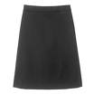 | image/jpeg | skirt.jpg | 09-MAY-2023 | -
6 | Ladies Shoes | Low heel and cushioned interior for comfort and style in simple yet elegant shoes | Womens  New line with HTML | Y | 120 | 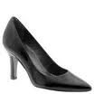 | image/jpeg | heels.jpg | 09-MAY-2023 | -
7 | Belt | Leather belt | Accessories  New line with HTML | Y | 30 | 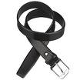 | image/jpeg | belt.jpg | 09-MAY-2023 | -
8 | Bag | Unisex bag suitable for carrying laptops with room for many additional items | Accessories  New line with HTML | Y | 125 | 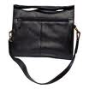 | image/jpeg | bag.jpg | 09-MAY-2023 | -
9 | Mens Shoes | Leather upper and lower lace up shoes | Mens  New line with HTML | Y | 110 | 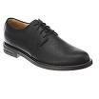 | image/jpeg | shoes.jpg | 09-MAY-2023 | -
10 | Wallet | Travel wallet suitable for men and women. Several compartments for credit cards, passports and cash | Accessories  New line with HTML | Y | 50 | 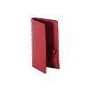 | image/jpeg | wallet.jpg | 09-MAY-2023 | -

