Simple demo for the usage of Loop tags in docx.
Order Receipt
Customer Name : William Hartsfield
Customer Address : Atlanta
Order 1
Product Name | Quantity | Unit Price | Image
Blouse | 4 | 60 | 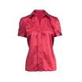
Skirt | 4 | 80 | 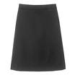
Ladies Shoes | 4 | 120 | 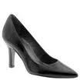
Order Total |  |  | 1640 USD
Order 2
Product Name | Quantity | Unit Price | Image
Blouse | 4 | 60
Skirt | 3 | 80
Bag | 2 | 125 | 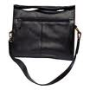
Order Total |  |  | 730 USD

